

z

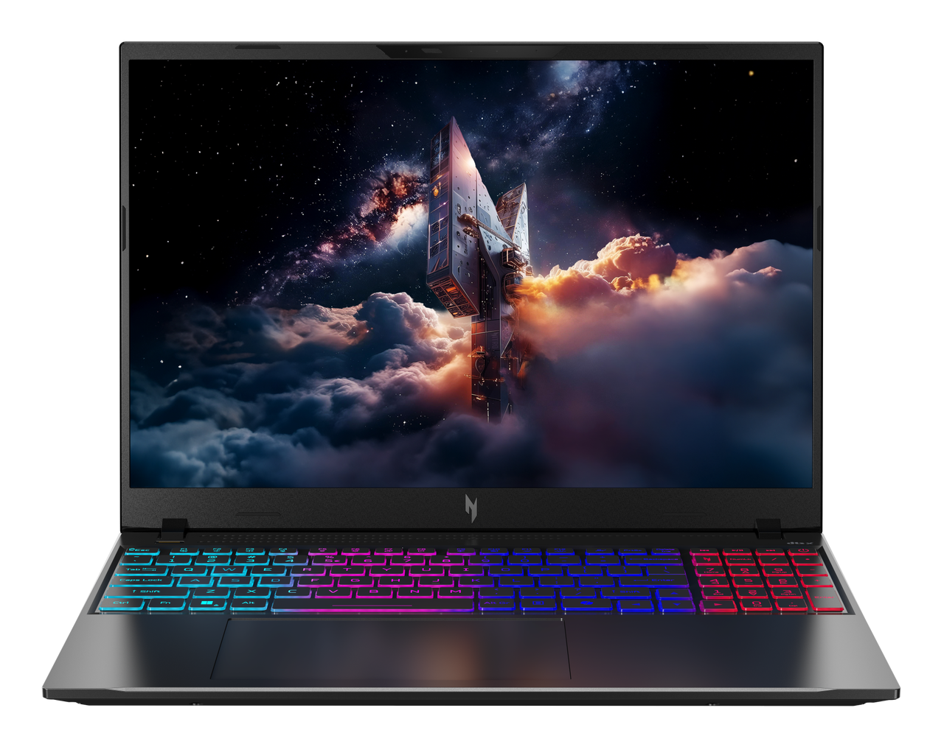

Acer Nitro V 16S AI

SPECIFICATIONS Acer Nitro V 16S AI ANV16S-I5
Acer NITRO V 16S ANV16S-71

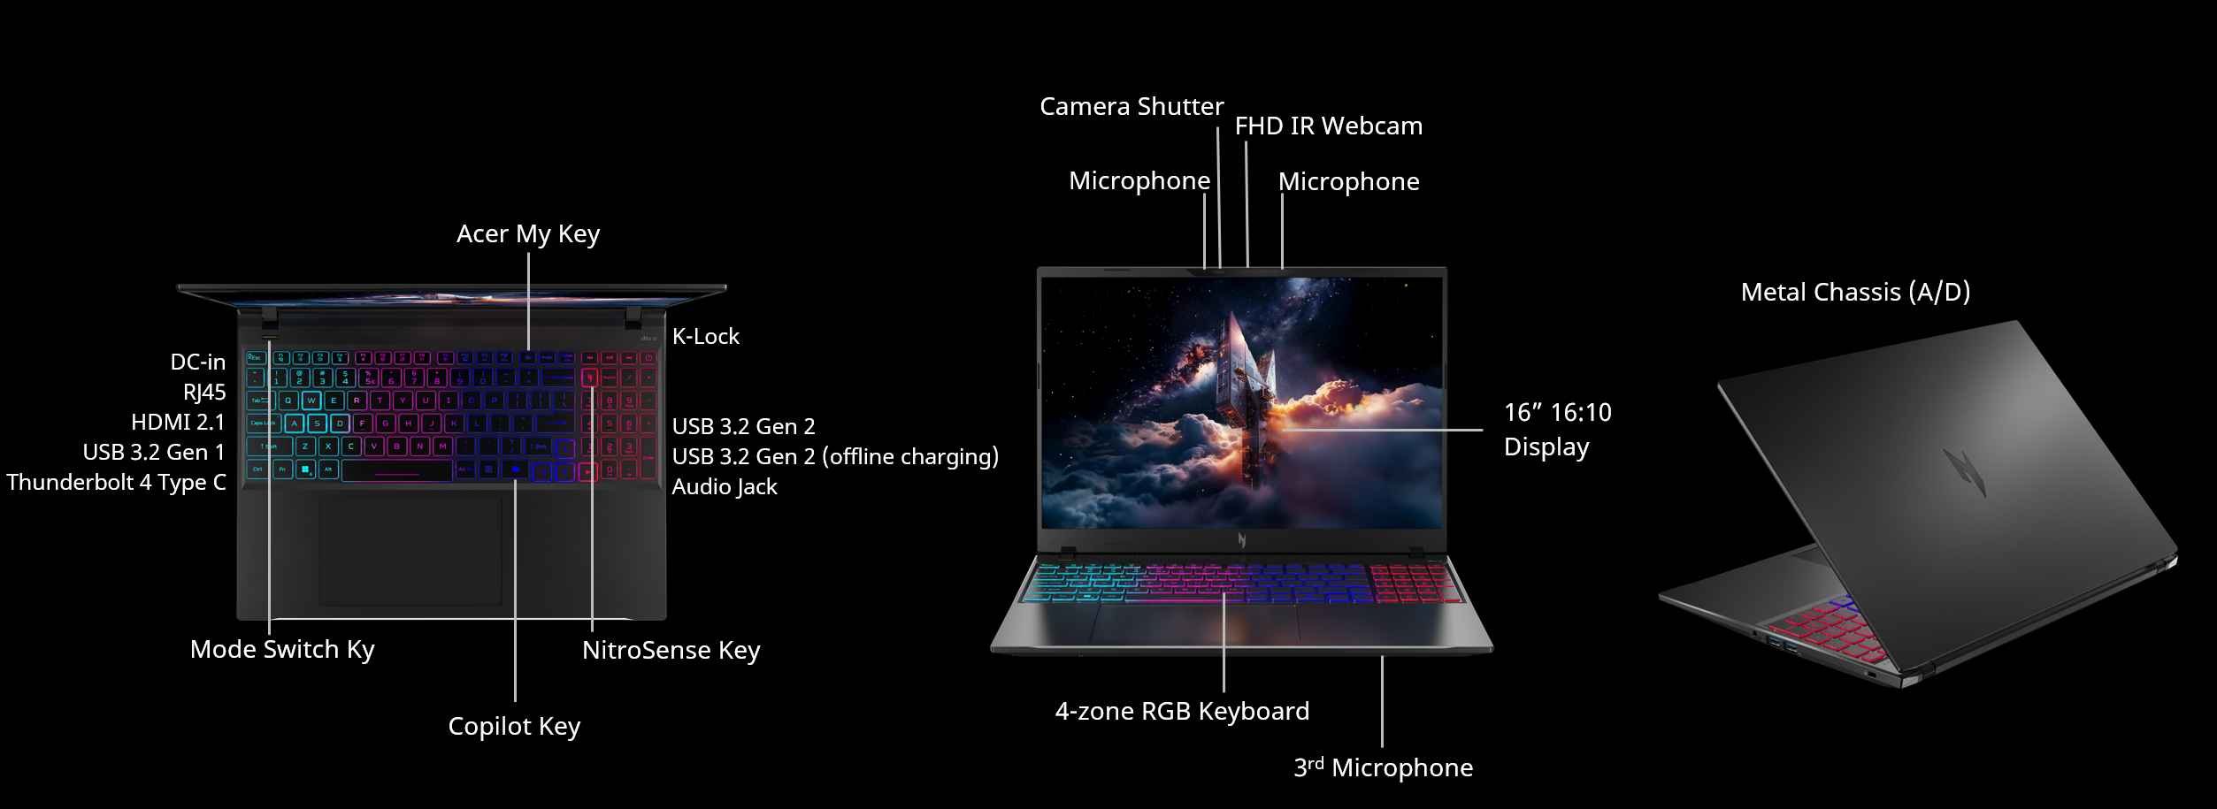
Operating System |  | Windows 11 Pro
CPU and Chipset |  | Intel® Core™ Ultra 5 processor 325  Intel® Core™ Ultra 7 processor 355
Memory |  | Up to 32 GB of DDR5 system memory using two soDIMM modules | Memory Frequency: Up to 5600 MT/s |  |  | Dual-channel DDR5 SDRAM support
Display |  | 16.0" display with IPS (In-Plane Switching) technology | WUXGA 1920 x 1200 | High brightness | Acer ComfyView™ LED-backlit TFT LCD | 180 Hz refresh rate | 3 ms G to G response time with overdrive | NVIDIA® Advanced Optimus capable  - 16:10 aspect ratio, sRGB 100%  - Wide viewing angle up to 170 degrees  - Ultra-slim design  - Mercury free, environment friendly |  |  |  |  | 16.0" display with IPS (In-Plane Switching) technology | WUXGA 1920 x 1200 | Acer ComfyView™ LED-backlit TFT LCD | 120 Hz refresh rate  - 16:10 aspect ratio, color gamut sRGB 100%"  - Wide viewing angle up to 170 degrees  - Mercury free, environment friendly
Graphics |  | NVIDIA® GeForce RTX™ 5060  NVIDIA® GeForce RTX™ 5070
Audio |  | DTS® X: Ultra Audio, featuring optimized Bass, Loudness, Speaker Protection with up to 6 custom content modes by smart amplifier |  |  | Supported in Windows Spatial Sound for PC Gaming with DTS  license integrated |  |  |  | Immersive audio rendering over headphones and internal speakers
 |  | High SNR DAC with 2.1 Vrms out capability and can driver high impedance headphone (up to 600 ohm)  Hi-Res Audio Certification by JAS (Headphone Output setting supported up to 24bit /192KHz) |  |  | Acer Purified Voice technology with AI noise reduction in dual built-in microphones. Features include far-field pickup, dynamic noise reduction through neural network, adaptive beam forming, and predefined personal and conference call modes. |  |  |  | Compatible with Cortana with Voice  Soundwire Codec with MSFT SDCA 1.0 driver supported  Acer TrueHarmony technology for lower distortion, wider frequency range, headphone-like audio and powerful sound
Storage |  | Solid state drive: 512 GB / 1 TB / 2 TB, PCIe Gen4, 16 Gb/s, NVMe
Webcam |  | UFC with Narrow USB FHD camera + IR camera with blue glass  Windows compatible only | 1920 × 1080 resolution | 1080p video fps with Temporal Noise Reduction | Blue glass lens | Staggered High Dynamic Range (SHDR) | Dual Mic (33 mm + 33 mm) | 88 × 3.2 × 2.6 mm
Wireless and Networking |  | WLAN:  Intel® Killer™ DoubleShot™ Pro  Killer™ Wireless Wi-Fi 6E 1675i  802.11 a/b/g/n/ac/ax wireless LAN  2.4 GHz, 5 GHz and 6 GHz bands  2x2 MU-MIMO technology  CNVi interface support | LAN:  Killer™ Ethernet E2600  10/100/1000 Mbps  Hibernation Mode Support  Wake On Lan Support  IPv4 and IPv6 Support |  |  | WPAN:  Supports Bluetooth® 5.4 or above
Security |  | Firmware Trusted Platform Module (TPM) solution | BIOS user, supervisor passwords | Camera Shutter | Kensington lock slot
Dimensions and Weight |  | Dimensions  356.5 (W) x 260 (D) x 10.34/17.99 (H) mm (14.04 x 10.24 x 0.41/0.71 inches) |  |  |  | Weight  2.1 kg (4.63 lbs.) with 4-cell battery pack
Power Adapter and Battery |  | Power Adapter  3-pin 180 W AC adapter  155.0 (W) x 76.0 (D) x 30.0 (H) mm (6.10 (W) x 2.99 (D) x 1.18 (H) inches)  588.5 g with 180 cm DC cable | Battery  76 Wh 4-cell Li-ion battery  For models with WUXGA Panel  Battery life:  Up to 8 hours (based on MobileMark® 2030 test results)  Up to 20 hours (based on video playback test results)
Input and Control |  | Keyboard  103 (US) / 104 (UK) / 107 (JP) keys | FineTip RGB-backlit keyboard | Independent numeric keypad | International language support  1.5 mm key travel  Programmable key design | Acer MyKey  Microsoft Copilot key  Dedicated NitroSense key  Special Nitro CMF keycap with transparent side view for enhanced RGB backlight performance  Caps Lock indicator  Microphone mute indicator  Function Lock key |  | Touchpad  Multi-gesture touchpad  Two-finger scroll  Pinch gesture  Microsoft Precision Touchpad certification  Moisture resistant |  |  |  | Control Keys  Programmable key | MyKey  Microsoft Copilot key  NitroSense key  Mode key
Windows Desktop Apps |  | In-House Applications  Acer LiveArt | Acer QuickPanel | Acer VisionArt | PredatorSense V5 (NB) |  |  |  | Tools  Acer My Key Application
Warranty |  | One-year International Travelers Warranty (ITW)
Disclaimers
• | Specifications vary depending on model.
• | Shared system memory may be allocated to support graphics, depending on system memory size and other factors. Actual system memory available to the operating system will be reduced by any memory used by the graphics solution and resources required by the operating environment.
• | Memory speed may vary, depending on the CPU, chipset or memory fitted.
• | All brands and product names mentioned herein include trademarks of their respective companies and are used solely to describe or identify the products.
• | 1 GB is 1 billion bytes. Actual formatted capacity is less and may vary depending on preloaded materials and operating environment. Acer Recovery Management uses a portion of the stated hard disk capacity as dedicated backup space.
• | Minor variations in system dimensions are possible due to the manufacturing process.
• | Weight may vary depending on product configuration, vendor components, manufacturing variability, and selected options.
• | Actual battery life may vary considerably depending on product model, configuration, applications, power management settings, operating conditions, and features utilized. Performance variation may also arise based on components in use, including but not limited to the processor, RAM capacity, storage, display, and resolution.
• | Bundled software may vary depending on hardware configuration, operating system, and regional availability.

Product Sheet is based on Nitro ANV16S-I51 Specifications (v1-0-0) (Preview)

